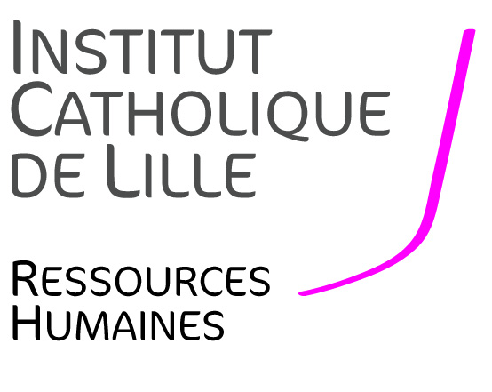
JOB OFFER
LECTURER/SENIOR LECTURER
IN ECONOMICS
(REF: ECO-CDD-21)

Full-time-one-year contract (CDD), starting September 1st, 2021
IN THE FACULTY OF MANAGEMENT, ECONOMICS AND SCIENCES
--------------------------------------

Context
The Faculty of Management, Economics and Sciences (FGES) of Lille Catholic University is hiring a full-time-one-year Lecturer/Senior Lecturer in Economics starting September 1st, 2021.
The FGES offers 7 Bachelor degree programs, 8 Master degree programmes as well as professional bachelor’s degrees in sciences, management, accounting and economics, and preparatory modules for admission into business schools. FGES welcomes 2,000 students each year. Student’s advice and support (e.g. through active teaching, student life, personal development and professionalization) and internationalization are a relevant part of University’s mission, which aims to educate professionals able to adapt, to innovate, to become active citizens and to be responsible for their actions. Teaching, research and consulting are also aimed at the diffusion of scientific culture and openness to socio-economic environment, which constitute a priority. FGES has also a research unit of about 30 people dedicated to “Smart and sustainable cities” investigating the current challenges in a systemic way, through three main axes: entrepreneurship, digital/energy transition, and urban ecology.
The Catholic University of Lille, with its 32,000 students, is a multidisciplinary university with five Faculties (Law, Humanities, Medicine, Management, Economics & Sciences, Theology), 20 Schools and Institutes, including medical and paramedical schools, social work, a Hospital Group, and overall around 50 research teams bringing together 650 researchers.
The candidate must have a doctorate/PhD in economics. He/she will teach in bachelor’s and master’s programmes in French and English. Teaching experience would be particularly appreciated. The ideal candidate will be able to conduct his/her own research contributing to the development of the research unit of the Faculty. His/her publications in international scholarly journals will demonstrate a solid research experience (with a minimum of two publications in HCERES ranked journals over the past four years).

Job description
Teaching and academic related missions:
- Teaching: lectures and seminars in French and English. A very good knowledge of French and English is essential.
- Attending to teaching responsibilities such as written and oral exams, preparing teaching support and making it available for pedagogic resources repository.
- Supervising Masters students’ dissertations and/or students’ projects.

Research:
The ideal candidate will be required to develop collaborative (eventually interdisciplinary) research with the other members of the research unit. The ideal candidate will publish in national and international scientific journals, following the HCERES and of the CNRS criteria.

Required skills and competencies
The following skills and competencies are required:
- Ph.D. in economics.
- Very good knowledge of French and English.
- Capacity to consider the environment and transforming it.
- Ability to work in a multidisciplinary team.
- Availability, commitment, and responsibility.
- Good interpersonal skills.

Application procedure
The candidate’s application will consist of the following elements:
- A letter of motivation in French or in English, including a description of ongoing research projects,
- A detailed CV comprising a list of publications, title, and date of the oral examination of the doctoral thesis,
- Three most relevant publications (two of which must be HCERES publications in the last 4 years),
- Contact information of two reference people willing to be contacted and provide recommendations.

Applications must be addressed in the form of a SINGLE pdf file to the two following email addresses: carine.ledoux@univ-catholille.fr and fges.recrutement@univ-catholille.fr. The deadline for submitting applications is June 15, 2021. Interviews will be held between June 15 to July 15 (the exact date will be communicated at a later stage). For any additional information or questions related to your application, please send your query to fges.recrutement@univ-catholille.fr mentioning reference ECO-CDD-21.

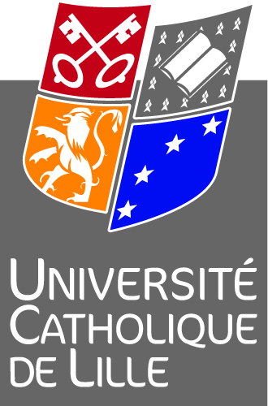

Direction des Ressources Humaines de l’Institut Catholique de Lille - 60 Bd Vauban – BP 109 – 59016 Lille Cedex
Madame Yolande MAGRIT – Directeur des Ressources Humaines- 03 59 31 50 11 carine.ledoux@univ-catholille.fr

