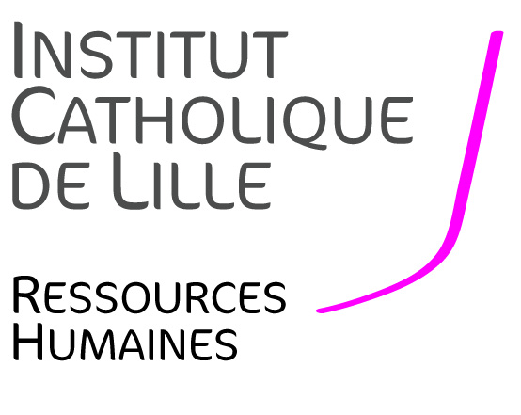
JOB OFFER
LECTURER
IN MANAGEMENT
(REF: SGEST20)

Full-time one-year contract (CDD), starting September 1st, 2020 with the possibility to continue with an open ended contract
IN THE FACULTY OF MANAGEMENT, ECONOMICS AND SCIENCES

--------------------------------------

Context
The Faculty of Management, Economics and Sciences (FGES) of Lille Catholic University is hiring a full-time Lecturer in Management starting September 1st, 2020.
The FGES offers 7 Bachelor degree programs, 8 Master degree programmes as well as professional bachelor’s degrees in sciences, management, accounting and economics, and preparatory modules for admission into business schools. FGES welcomes 2,000 students each year. Student’s advice and support (e.g. through active teaching, student life, personal development and professionalization) and internationalization are a relevant part of University’s mission, which aims to educate professionals able to adapt, to innovate, to become active citizens and to be responsible for their actions. Teaching, research and consulting are also aimed at the diffusion of scientific culture and openness to socio-economic environment, which constitute a priority. FGES has also a research unit of about 30 people dedicated to “Smart and sustainable cities” investigating the current challenges in a systemic way, through three main axes: entrepreneurship, digital/energy transition, and urban ecology.
The Catholic University of Lille, with its 32,000 students, is a multidisciplinary university with five Faculties (Law, Humanities, Medicine, Management, Economics & Sciences, Theology), 20 Schools and Institutes, including medical and paramedical schools, social work, a Hospital Group, and overall around 50 research teams bringing together 650 researchers.
The ideal candidate will be able to conduct his/her own research contributing to the development of the research unit of the Faculty. The candidate must have a doctorate/PhD in management. His/her research will contribute to the research of FGES.
Teaching experience would be particularly appreciated. He/she will teach in bachelor’s and master’s programmes in English and should be able to deliver courses in:
- Social Economy;
- Social Business ;
- Intercultural Management ;
- International Negotiation ;
- Organizational Behaviour.

Job description
Teaching and academic related missions:
- Teaching in management or business: lectures and seminars in English. A very good knowledge of English is essential.
- Attend to teaching responsibilities such as written and oral exams, preparing teaching support and making it available for pedagogic resources repository.
- Supervise Master’s students’ dissertations and/or student projects
- Possibility to take on responsibilities over time (program leader for example)

Research:
The ideal candidate is expected to contribute to the research of FGES. The ideal candidate will publish in national and international scientific journals, following the HCERES and of the CNRS criteria and be interested to collaborate with colleagues.

Required skills and competencies
The following skills and competencies are required:
- Ph.D. in management
- Very good knowledge of English
- Capacity to consider the environment and transforming it
- Ability to work in a multidisciplinary team.
- Availability, commitment and responsibility.
- Good interpersonal skills.
Application procedure
The candidate’s application will consist of the following elements:
- A letter of motivation in French or in English, including a description of ongoing research projects,
- A detailed CV comprising a list of publications, title and date of the oral examination of the doctoral thesis,
- Publications,
- Contact information of two reference people willing to be contacted and provide recommendations.

Applications must be addressed in the form of a SINGLE pdf file to the two following email addresses: carine.ledoux@univ-catholille.fr and fges.recrutement@univ-catholille.fr. The deadline for submitting applications is July 10th, 2020. Interviews will be held during the last two weeks of July (the exact date will be communicated at a later stage). For any additional information or questions related to your application, please send your query to fges.recrutement@univ-catholille.fr mentioning reference SGEST20.
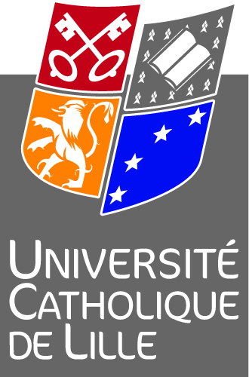

Direction des Ressources Humaines de l’Institut Catholique de Lille - 60 Bd Vauban – BP 109 – 59016 Lille Cedex
Madame Yolande MAGRIT – Directeur des Ressources Humaines- 03 59 31 50 11 carine.ledoux@univ-catholille.fr

