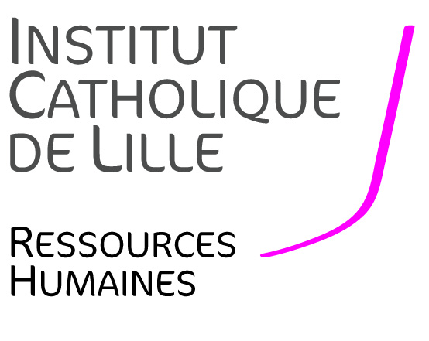
JOB OFFER
LECTURER/SENIOR LECTURER
IN MANAGEMENT OR ECONOMICS
(REF: ECOGEST2020)

Full-time permanent contract (CDI), starting September 1st, 2020
IN THE FACULTY OF MANAGEMENT, ECONOMICS AND SCIENCES

--------------------------------------

Context
The Faculty of Management, Economics and Sciences (FGES) of Lille Catholic University is looking to hire a full-time Lecturer/Senior Lecturer in Management or Economics starting September 1st, 2020.
The Faculty offers 7 bachelor’s degrees, 8 master’s degrees and professional bachelors in science, management, accounting and economics and preparatory classes for business schools. Every year, the Faculty hosts 2,000 students. Student accompaniment (active pedagogy, student life, personal and professional development) and internationalization are all part of the University’s main mission to train professionals capable of adapting, innovating and becoming active and responsible citizens. Spreading a scientific culture and a general openness towards socio-economic issues is also a priority stimulated through teaching, research and consulting. The research unit in the FGES works on Sustainable and Smart Cities, defined widely. Its three main axes are entrepreneurship, digital and energy transition and urban ecology. It is made up of around 30 members.
The Catholic University of Lille with its 32,000 students is a multidisciplinary university with five Faculties (Law, Humanities, Medicine, Management, Economics & Sciences, Theology), 20 Schools and Institutes including medical and paramedical schools, social work, a Hospital Group, and in all, around 50 research teams bringing together 650 researchers.

The ideal candidate will be able to conduct his/her own research contributing to the development of the research unit of the Faculty. He/she will integrate the LEM (Lille-Economie-Management) lab (CNRS, UMR 9221) of which the Faculty is a co-founding member. The candidate must have a doctorate/PhD in management or economics. His/her publications in international scholarly journals will demonstrate a solid research experience (with a minimum of two publications in HCERES ranked journals over the past four years). His/her research will have to be in line with the research areas of the LEM and he/she is expected to contribute to the Faculty’s research programme on Smart and Sustainable Cities.

Teaching experience would be particularly appreciated. He/she will teach in bachelor’s and master’s programmes. All areas of specialisation will be considered.

Job description
Teaching and academic related missions:
- Teaching in management or economics: lectures and seminars in French and/or English. A very good knowledge of French and English is essential.
- Attend to teaching responsibilities such as written and oral exams, preparing teaching support and making it available for pedagogic resources repository.
- Supervise Master’s students’ dissertations and/or student projects
- Possibility to take on responsibilities over time (program leader for example)

Research:
The person brought on is expected to contribute to the research axes of the LEM and to the research programme on Smart and Sustainable Cities relatively soon. Expertise in the field of social impact assessment would be appreciated.
The ideal candidate will be required to develop collaborative (interdisciplinary) research with the other members of the research unit.
The ideal candidate will publish in national and international scholarly journals, following the HCERES and of the CNRS criteria.

Required skills and competencies
The following skills and competencies are required:
- Ph.D. in management or economics
- Very good level in French and English
- Ability to take into account an environment and to help it evolve.
- Ability to work in a multidisciplinary team.
- Availability and sense of commitment and responsibility.
- Good interpersonal skills.

Application procedure
The candidate’s application will consist of the following elements:
- A letter of motivation in French or in English, including a description of ongoing research projects,
- A detailed CV comprising a list of publications, title and date of the oral examination of the doctoral thesis,
- A report of thesis defence,
- Three publications,
- The complete contact information of two persons who can provide a letter of recommendation.

Applications are to be addressed in the form of a SINGLE pdf file to the two following email addresses: carine.ledoux@univ-catholille.fr and fges.recrutement@univ-catholille.fr. The deadline for submitting applications is February 14th, 2020. Interviews will be held during the last two weeks of March (the exact date will be communicated later). For any additional information or any questions relating to your application, please send your query to fges.recrutement@univ-catholille.fr mentioning reference ECOGEST2020.

Direction des Ressources Humaines de l’Institut Catholique de Lille - 60 Bd Vauban – BP 109 – 59016 Lille Cedex
Madame Yolande MAGRIT – Directeur des Ressources Humaines- 03 59 31 50 11 carine.ledoux@univ-catholille.fr

