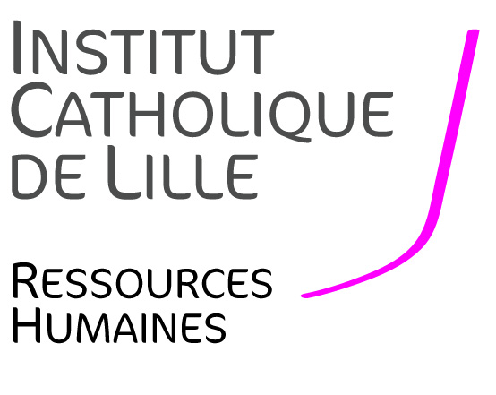
HIRING AD
Lecturer in Technologies of Information and Communication

FACULTY OF MANAGEMENT, ECONOMICS AND SCIENCES
--------------------------------------

Background Information
The Faculty of Management, Economics and Sciences (FGES hereafter) opens a new position for an associate professor/Lecturer in Management Sciences.
The FGES is a faculty, which proposes 7 bachelor’s degree programmes, 8 masters’ degree programmes and professional bachelor’s degree in sciences, management, accountability and economics, and preparatory classes for business class. The FGES has 1,700 students each year. Comprehensive advice and support (active teaching, student life, personal development and professionalization) and internationalization are part of the University mission which aims to educate professional able to adapt, to innovate, to become active citizens and to be responsible for their actions.
The research of the FGES is focused on issues pertaining to sustainable and smart city.

Missions
Teaching Activities:

- To contribute to the transformation of the different programmes by adding, if necessary the digital dimension, in order to continuously adapt to new jobs and skills.
- To teach courses in the digital communication programme (computer science, digital communication and/or e-commerce or digital marketing …): lecture, tutorial, seminars and conferences in English and/or French.
- To comply with the obligations arising from pedagogy such as marking exams, evaluating student’s oral communications, preparing course supports and posting them on the teaching platform.
- To comply with the obligations arising from student comprehensive advice: tutorial, student supervision, managing projects and following-up on assignments and student’s work.

Faculty life- Services to the Faculty
The hired candidate will:
- Participate to FGES‘s life : meetings, prospection, promotion and representation of FGES.
- Participate to the life and animation of l’Université Catholique de Lille: transverse meetings, general meetings…

Research:
We are looking for someone who will conduct a research activity within our research centre on « Smart and Sustainable Cities » and who will
- Publish in national and international reviews, following HCERES and CNRS standards
  - Develop a research activity and wish to co-write on smart city/sustainable city
  - Collaborate with the FGES research team.

The Faculty offers many opportunities for career development for staff with an academic profile.

Expected Skills and Qualities
Applications in all IT fields will be studied. Applicants should however respond to the following characteristics:
- Doctorate in I.T., or PhD.
- Teaching Experience.
- Capacity to take into account the environment and transforming it
- Capacity to work in team.
- Availability and commitment.
- Capacity to communicate and teach in English
- Conduct a research activity

Application package (Motivation letter and C.V. (education, description of research work, courses and publications, thesis defence report) to send to:

Direction of Ressources Humaines de l’Institut Catholique de Lille - 60 Bd Vauban – BP 109 – 59016 Lille Cedex
Madame Yolande MAGRIT – Directeur des Ressources Humaines
03 59 31 50 11 carine.ledoux@univ-catholille.fr

03 59 31 50 11 – carine.ledoux@univ-catholille.fr

