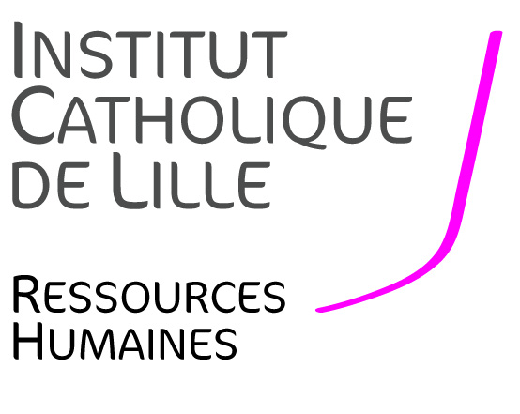
LECTURER /SENIOR LECTURER
IN ACCOUTING / MANAGERIAL CONTROL
JOB OFFER

Under permanent contract, full-time, starting September 15th, 2018
IN THE FACULTY OF MANAGEMENT, ECONOMICS AND SCIENCES

--------------------------------------

Context
The Faculty of Management, Economics and Sciences (FGES) is looking to hire a full-time Lecturer/Senior Lecturer in Management starting September 15th, 2018.
The Faculty offers 7 bachelor’s degrees, 8 master’s degrees and professional bachelors in science, management, accounting and economics and preparatory classes for business schools. Every year, the Faculty hosts 1,700 students. Student accompaniment (active pedagogy, student life, personal and professional development) and internationalization all are part of the University’s main mission to train professionals The Faculty offers 7 bachelor’s degrees, 8 master’s degrees and professional bachelors in science, management, accounting and economics and preparatory classes for business schools. Every year, the Faculty hosts 1,700 students. Student accompaniment (active pedagogy, student life, personal and professional development) and internationalization are all part of the University’s main mission to train professionals capable of adapting, innovating and becoming active and responsible citizens. Spreading a scientific culture and a general openness towards socio-economic issues is also a priority stimulated through teaching, research and consulting. The research unit in the FGES works on Sustainable and Smart Cities, defined widely. Its three main axes are entrepreneurship, digital and energy transition and urban ecology. It is made up of around 30 members.
The Catholic University of Lille with its 29,000 students is a multidisciplinary university with five Faculties (Law, Humanities, Medicine, Management, Economics & Sciences, Theology), 20 Schools and Institutes including medical and paramedical schools, social work, a Hospital Group, and in all, around 50 research teams bringing together 650 researchers.

The ideal candidate will be able to conduct his/her own research contributing to the development of the research unit of the Faculty. He/she will integrate the LEM (Lille-Economie-Management) lab (CNRS, UMR 9221) of which the Faculty is a co-founding member. The candidate must have a doctorate/PhD in management sciences. His/her publications in French and international scholarly journals will demonstrate a solid research experience (with a minimum of two publications in HCERES ranked journals over the past four years). Teaching experience would be particularly appreciated, especially in the domains of accounting and managerial control. The ideal candidate will teach at both bachelors’ and masters’ level.

Job description
Teaching activities and student follow-up:
- Teaching in management: lectures and seminars in French and/or English. Attend to teaching responsibilities such as written and oral exams, preparing teaching support and making it available for pedagogic resources repository.
- Supervise Master’s students’ dissertations and/or student projects.

- Willing to assume the role of academic advisor would be a real asset.

Research:
The person brought on will need to contribute to the research programme on Smart and Sustainable Cities, defined in a broad sense (for example, global performance evaluation in line with GRI/ISO 26000/IIRC integrated reporting, innovation, competitiveness, and governance).

The ideal candidate will be required to develop collaborative (interdisciplinary) research with the other members of the research unit.

The ideal candidate will publish in national and international scholarly journals, following the HCERES and the CNRS criteria.

Required skills and competencies
The following skills and competencies are required:
- Ability to take into account an environment and to help it evolve.
- Ability to work in a multidisciplinary team.
- Availability and sense of commitment and responsibility.

Application procedure
The candidate’s application will consist of the following elements:
- A letter of motivation in French or in English, including a description of ongoing research projects,
- A detailed CV comprising a list of publications, title and date of the oral examination of the doctoral thesis,
- A report of thesis defence,
- Three publications,
- The complete contact information of two persons who can provide a letter of recommendation.

Applications are to be addressed in the form of a SINGLE pdf file to the two following addresses: carine.ledoux@univ-catholille.fr and fges.recrutement@univ-catholille.fr. The deadline for submitting applications is July 13th 2018. Interviews will be held the week of July 23rd (the exact date will be communicated later). For any additional information or any questions relating to your application, please send your query to fges.recrutement@univ-catholille.fr .

Address of Human Resources of the Catholic Institute of Lille - 60 Bd Vauban – BP 109 – 59016 Lille Cedex
Madame Yolande MAGRIT – Director of Human Resources - 03 59 31 50 11 carine.ledoux@univ-catholille.fr

